Module 4(CSS)

1. **What are the benefits of using CSS?**

* Separation of Content and Style
* Consistency
* Responsive Design
* Animations and Effects
* It reduces the file transfer size.

1. **What are the disadvantages of CSS?**

* With CSS, what works with one browser might not always work with another**.**
* Browser Compatibility
* Lack of Security
* Limited Layout Control
* Overriding Styles

1. **What is the difference between CSS2 and CSS3?**

**Ans:**

|  |  |
| --- | --- |
| **CSS 2** | **CSS 3** |
| * CSS2 which was comprised of a single document | * CSS3 has its specifications divided into many individual modules, which makes CSS3 a whole lot easier to handle. |
| * CSS2, designers could only use “web-safe fonts” for being 100% sure to use fonts that would always display the same on every machine. | * With CSS3, the designers can now use special fonts, like those available in Google Fonts and Typecast. |
| * CSS2 had ‘simple selectors’. | * CSS3 calls the components as ‘a sequence of simple selectors’**.** |
| * In CSS2, the developers had difficulty because the standard was not equipped with automatically breaking the text so that it fits within a box. | * CSS3 has the capability to split text sections into multiple columns so that it can be read like a newspaper. |

1. **Name a few CSS style components**

**Ans:**

* Selectors
* CSS border
* Margin
* Padding
* Positioning
* Font size
* Background image
* Flex
* Grid

1. **What do you understand by CSS opacity?**

**Ans:** The opacity property sets the opacity level for an element. The opacity-level describes the transparency-level, where 1 is not transparent at all, 0.5 is 50% see-through, and 0 is completely transparent.

1. **How can the background color of an element be changed?**

**Ans:** We can set background color by selecting the element by its class name of id name and then apply the background-color property on it to set the background color.

Syntax: background-color: color_name;

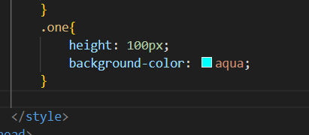

1. **How can image repetition of the backup be controlled?**

**Ans:** The background-repeat property in CSS is used to repeat the background image both horizontally and vertically. It also decides whether the background image will be repeated or not.

Syntax:

background-repeat: repeat|repeat-x|repeat-y|no-repeat|initial|inherit;

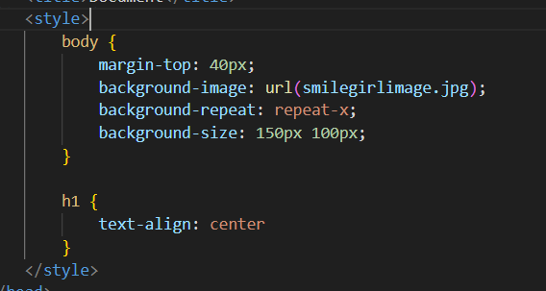

1. **What is the use of the background-position property?**

**Ans:** The background-position property in CSS is mainly used to sets the initial position for the background image. It is used to set an image at a certain position.

Syntax:

background-position: value;

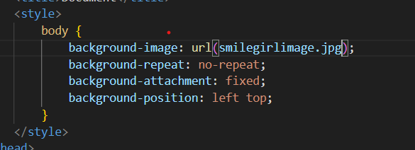

1. **Which property controls the image scroll in the background?**

**Ans:** The background-attachment property in CSS is used to specify the kind of attachment of the background image with respect to its container. It can be set to scroll or make it remain fixed. It can be applied to all HTML elements.

Syntax:

background-attachment: scroll|fixed|local|initial|inherit;

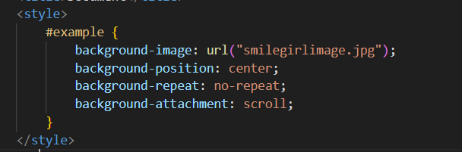

1. **Why should background and color be used as separate properties?**

**Ans:** The CSS color is used to change the text color of a html element. In this example "This is my text" would be red. The CSS background-color is used to change the background color so in this case you would get a black box with red text inside it.

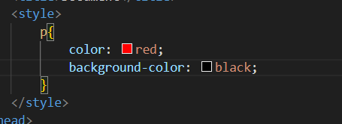

1. **How to center block elements using CSS1?**

**Ans:** We have one property value “auto” which will automatically set the margin such that our block element is placed in the center.

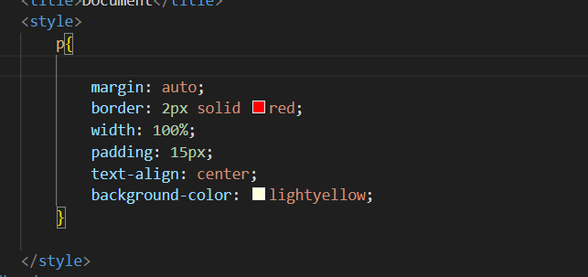

1. **How to maintain the CSS specifications?**

**Ans**: The CSS specifications are maintained by the World Wide Web Consortium**.** The Specification also include: The syntax and data types of the language.

1. **What are the ways to integrate CSS as a web page?**

**Ans:**

* Inline CSS

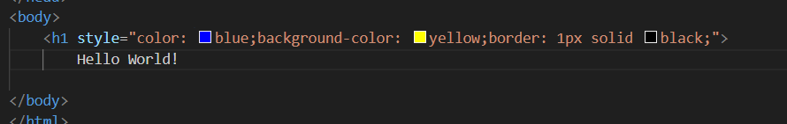

* Internal CSS

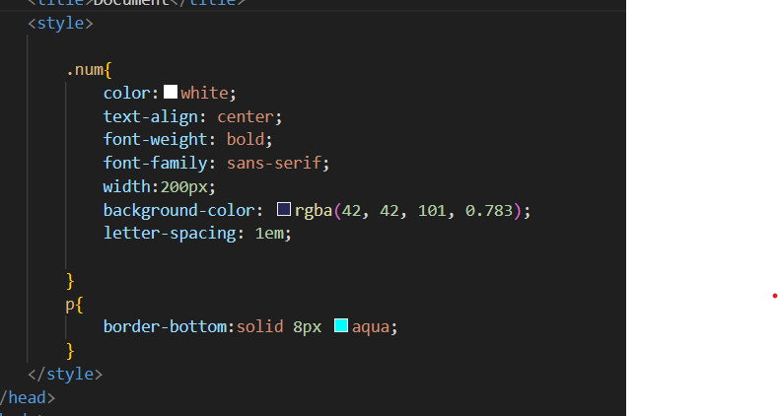

* External CSS

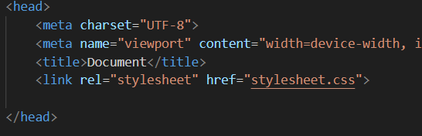

1. **What is embedded style sheets?**

**Ans:**  It allows to define styles for a particular HTML document as a whole in one place. This is done by embedding the <style></style> tags containing the CSS properties in the head of document.

Syntax:

<style>

------

------

</style>

1. **What are the external style sheets?**

**Ans:** An external style sheet is a separate CSS file that can be accessed by creating a link within the head section of the webpage.



1. **What are the advantages and disadvantages of using external style sheets?**

**Ans:**

* **Advantages of External CSS:**
* In External Style Sheets, Classes can be made for use on numerous HTML element types in many forms of the site.
* With the help of External Style Sheets, the styles of numerous documents can be organized from one single file.
* In complex contexts, Methods like selector and grouping can be implemented to apply styles.
* **Disadvantages of External CSS:**
* An extra download is essential to import style information for each file**.**
* The execution of the file may be deferred till the external style sheet is loaded.
* While implementing style sheets, we need to test Web pages with multiple browsers in order to check compatibility issues.

1. **What is the meaning of the CSS selector**?

**Ans**: CSS selectors are used to select the content you want to style. Selectors are the part of CSS rule set. CSS selectors select HTML elements according to its id, class, type, attribute etc.

There are several different types of selectors in CSS.

* **CSS Element Selector**

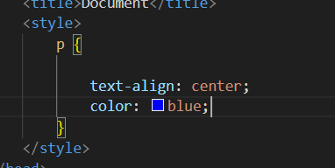

* **CSS Id Selector**

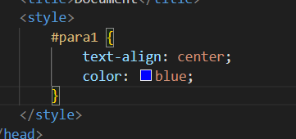

* **CSS Class Selector**

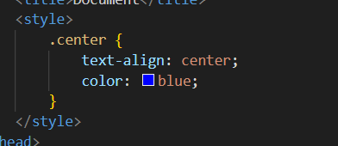

* **CSS Universal Selector**

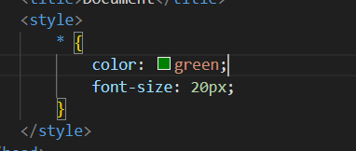

* **CSS Group Selector**

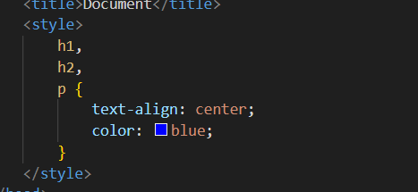

1. **What are the media types allowed by CSS?**

**Ans:** CSS media queries allows the styling of elements depending on the devices. It helps to create a responsive web design. It means that the view of a web page differs from system to system based on screen or media types.

**Media types:**

* **All**
* **Print**
* **Screen**
* **Speech**

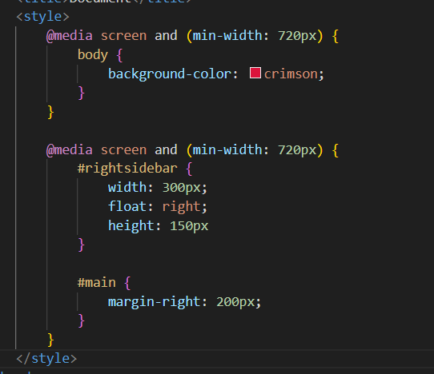

1. **What is the rule set?**

**Ans:** A CSS ruleset is various affirmations to various pieces or elements of the document. The objective is to apply a bunch of properties for certain distinct qualities to a solitary, or a particular arrangement of components in the connected HTML page.

